Enabling use of OpenMP with Visual Studio

## Update MinGW if using Windows

The “streamlined” version of MinGW that is included with Code::Blocks needs to be changed to one that has the OpenMP Libraries.

Find the MinGW folder, this will be in Code::Block’s Program Files.

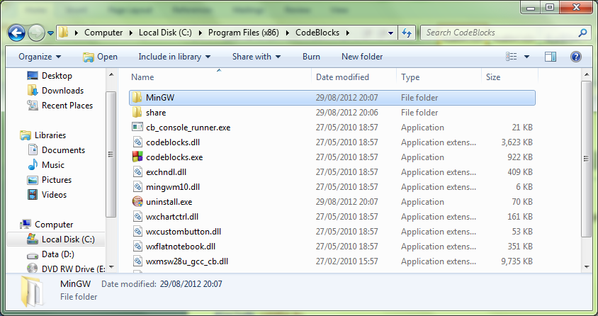

Delete the “MinGW” folder.

Download MinGW from <http://www.mingw.org/>

Install it (Make sure you include the C++ option) and remember the location chosen for the binaries, in my case C:\MinGW\

Copy C:\MinGW\ to replace the folder you previously deleted in C:\Program Files(x86)\CodeBlocks\

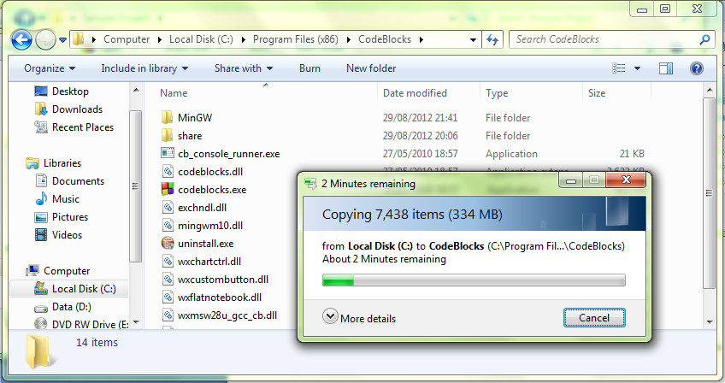

## Setting up your Project

Create a new project containing the code:

#include <omp.h>

#include <stdio.h>

int main() {

#pragma omp parallel

printf("Hello from thread %d, nthreads %d\n",

omp_get_thread_num(), omp_get_num_threads());

}

Building and running this should give:

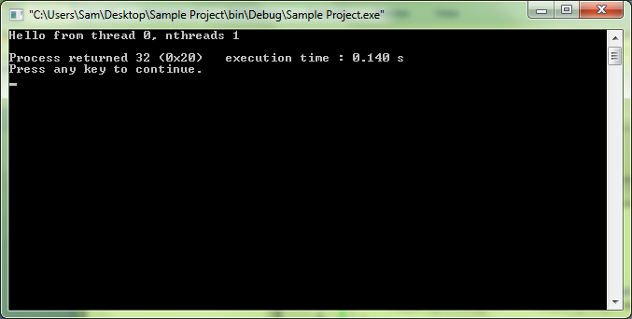

Right click on the current Project and select “Build Options...”:

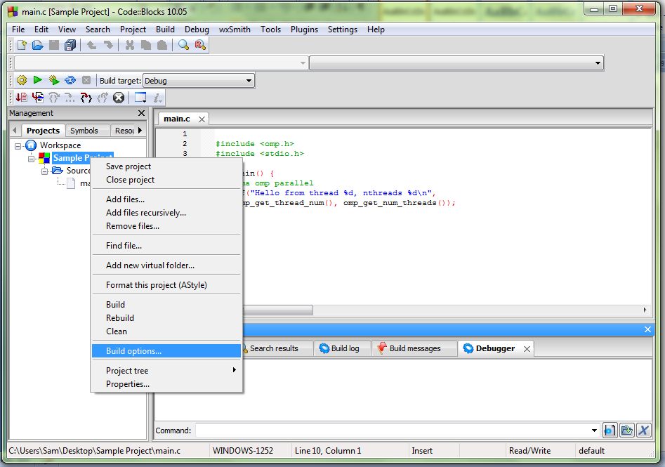

Select the Current Project on the left hand side of the dialog, and then the GNU GCC compiler, Compiler settings, Other Options tabs respectively.

Add “-fopenmp” to the text area and click OK.

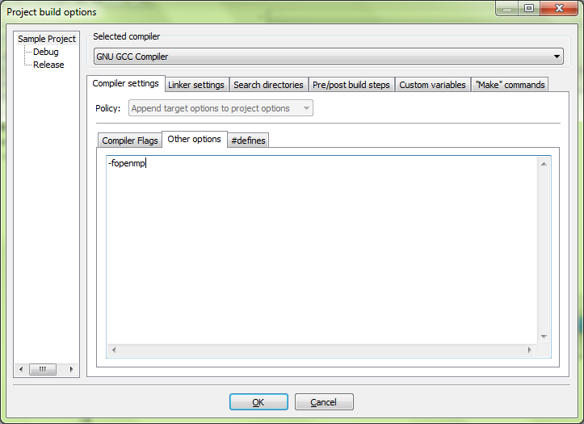

Open the “Linker” Tab and goto “Add” a library, browse to find it and change the view to show “All Files (*.*)”

Select the "C:\Program Files (x86)\CodeBlocks\MinGW\bin\libgomp-1.dll" Library (your path may vary).

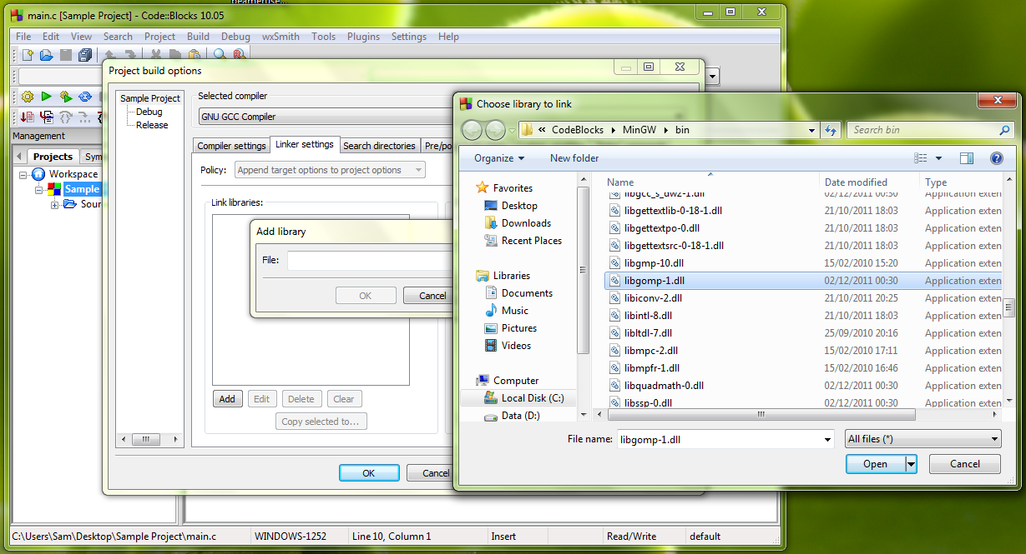

Now re-build and run the project and – assuming you have a multi-processor machine – the output should be different.

